**CROSS DOMAIN USE CASE**

LUCIA lives in perugia (northern apennines, Italy)

* SHE WANTS TO KNOW WHICH ARE THE RESEARCH INFRASTRUCTURES MONITORING EARTH INSTABILITIES (E.G. EARTHQUAKES) NEARBY HER HOME
* LUCIA DOES A WEB RESEARCH SHOWING THE EPOS (ICS) WEB SITE

Step 1 - spatial search (map based)

* LUCIA PERFORMS A SPATIAL RESEARCH (LATITUDE LONGITUDE AROUND PERUGIA, ITALY)

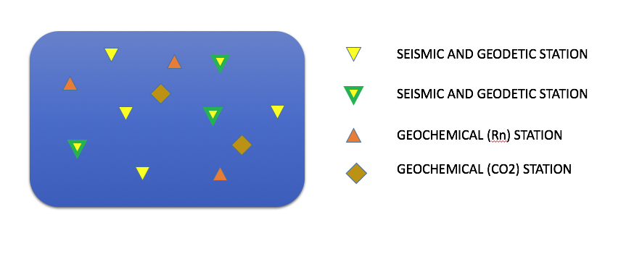

seismic station

sesimic and geodetic station

Geochemical (Rn) station

Geochemical (co2) station

How does Lucia know which infrastructures she can search for?

- start from 'show all' , including a list of available 'recording station types' (seismic, geodetic, geochemical, geomagnetic, ...) - do we have a complete list of station types in EPOS? (Is the 'type' (domain) parameter available in the metadata?)

(geographical) search options: lat-lon rectangle | point+radius | polygon - which ones to support?

Step 2 - metadata retrieval

* LUCIA cliks to find out the station charactreristics (FDSN station – GLASS GNSS station – geochemical station info) and where/HOW She could get the data from (e.g. ICS SITE ITSELF oR EIDA, GLASS and FRIDGE)

What happens on 'click' (on station symbol?)?

- popup window in graphic or separate pane on website?

- is the full metadata (response of query to fdsnws-station for a particular station (and time)) shown or only some (pre-selected) parameters?

- should it be possible to 'save to file' the station description (so that Lucia can inspect it more carefully offline)?

'access to data' should ideally be 'transparent' to the user (maybe not now but some time in the future)? 'direct data access' provided by TCS services, but some 'get_data' wrapper available on ICS?

how to get data should be described on the ICS platform (tutorial / FAQ / howTo pages ...)?

Step 3 - service invocation

* LUCIA is interested in the seismic data in terms of earthqaukes activity so she asks for the events occurred IN the area (ICS has to talk with a FDSN event)

What other parameters are needed as a minimum? (time-interval?)  
Allow other selection parameters? (magnitude, min #stations with data (within a given distance), ...)

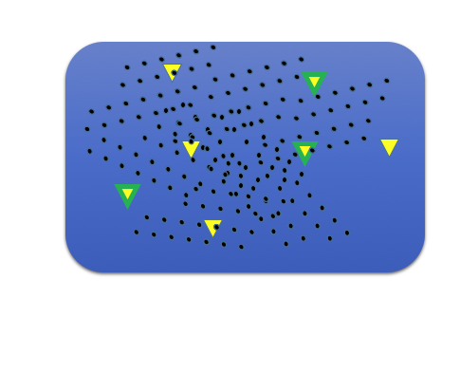

Step 4 - parameter (data) retrieval

* LUCIA is interested in understanding the size (e.g. magnitude) of the events so She clicks on the points (Origin time, lat lon mag …)

What happens on 'click' on event symbol? (see same question above for station)

- full set of event description (quakeML BED) is too much - need pre-defined subset.

- where does the information appear - pop-up in graphic (what happens with that if another event is clicked) or text in separate pane?

It should be possible to 'save to file' the list of earthquakes shown on the plot

Step 5 - (map) layer combination

* LUCIA wants to see if there is any correlation between seismic events and surface geology (sorry but LUCIA is not a scientist :-) so she overlays a geological map of the area

Overlay function attributes: transparency, layer order,

map legend attributes on/off (per layer)? in separate window?

Step 6 - parameter time series generation

* then LUCIA is inteersted in understanding the events occurrence so she asks for a plot showing the number of events versus time (e.g. time series showing number of events per day in the selected area)

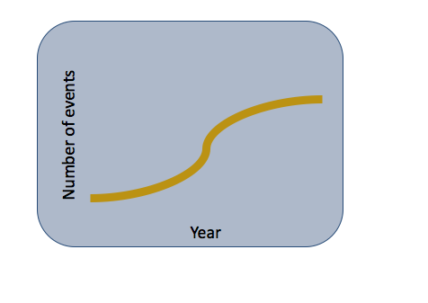

Step 7 - service invocation & overlay (combines step 3 & 5)

* LUCIA is inteersted in understanding if this area was INTEREStED by seismic activity in the past (e.g. historical earthquakes from ahead)

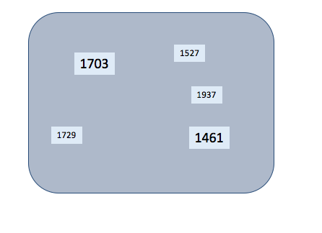

...further steps (combining functionality from prev. ones)

* LUCIA is inteersted in understanding the size (e.g. magnitude) of the events, the closest villages
* LUCIA doesn’t know the geochemical stations thus she goes back to map 1 and click on one of the co2 geochemical stations
* she reads the description and then she wants to see the co2 release versus time compared to the meteo temperature (e.g. time series swhowing the co2 values versus time using the declared sampling rate measurement)

**LUCIA is happy and now she is ready to vote for remaining in EU!!**